# Kyle Cortez

# CS 255 System Design Document

## UML Diagrams

### UML Use Case Diagram

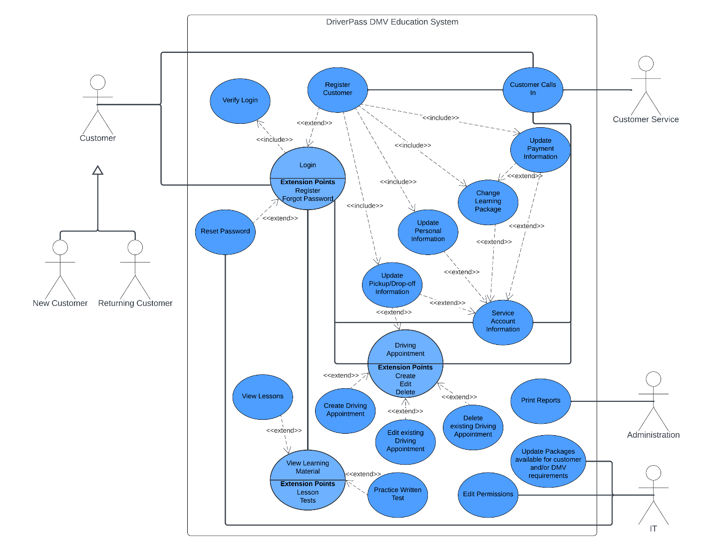

### UML Activity Diagrams

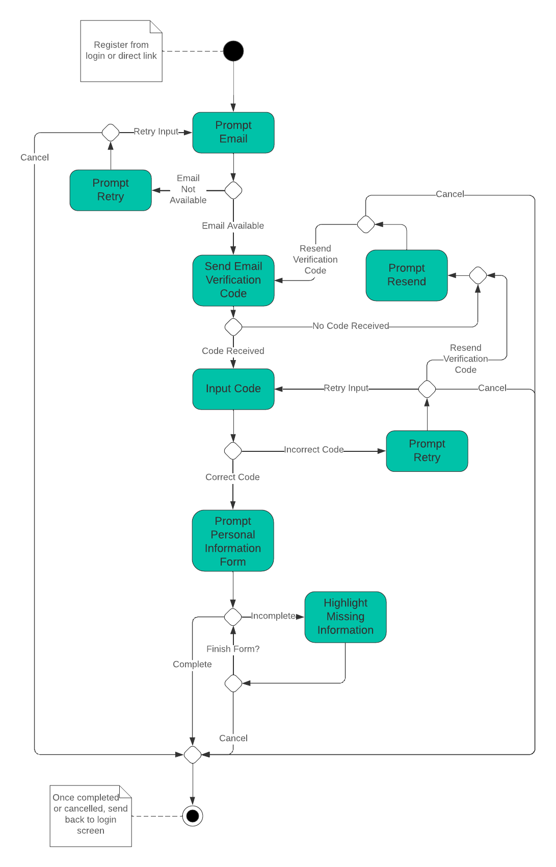

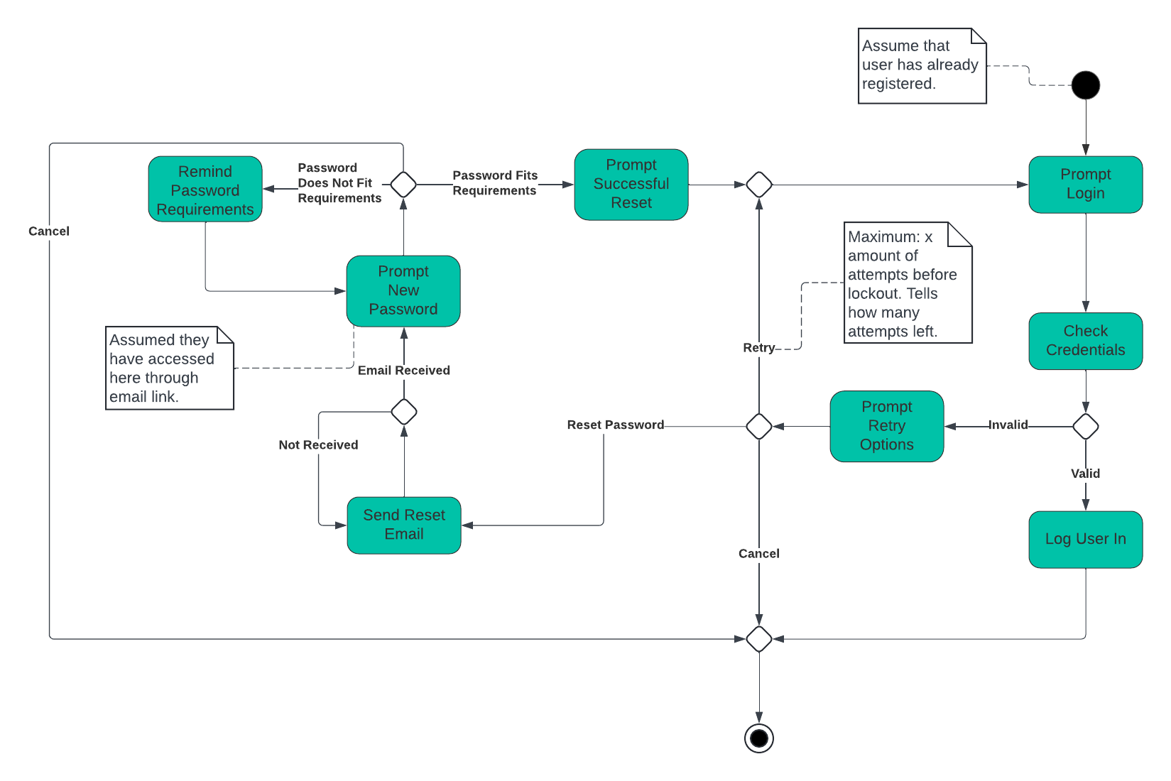

### UML Sequence Diagram

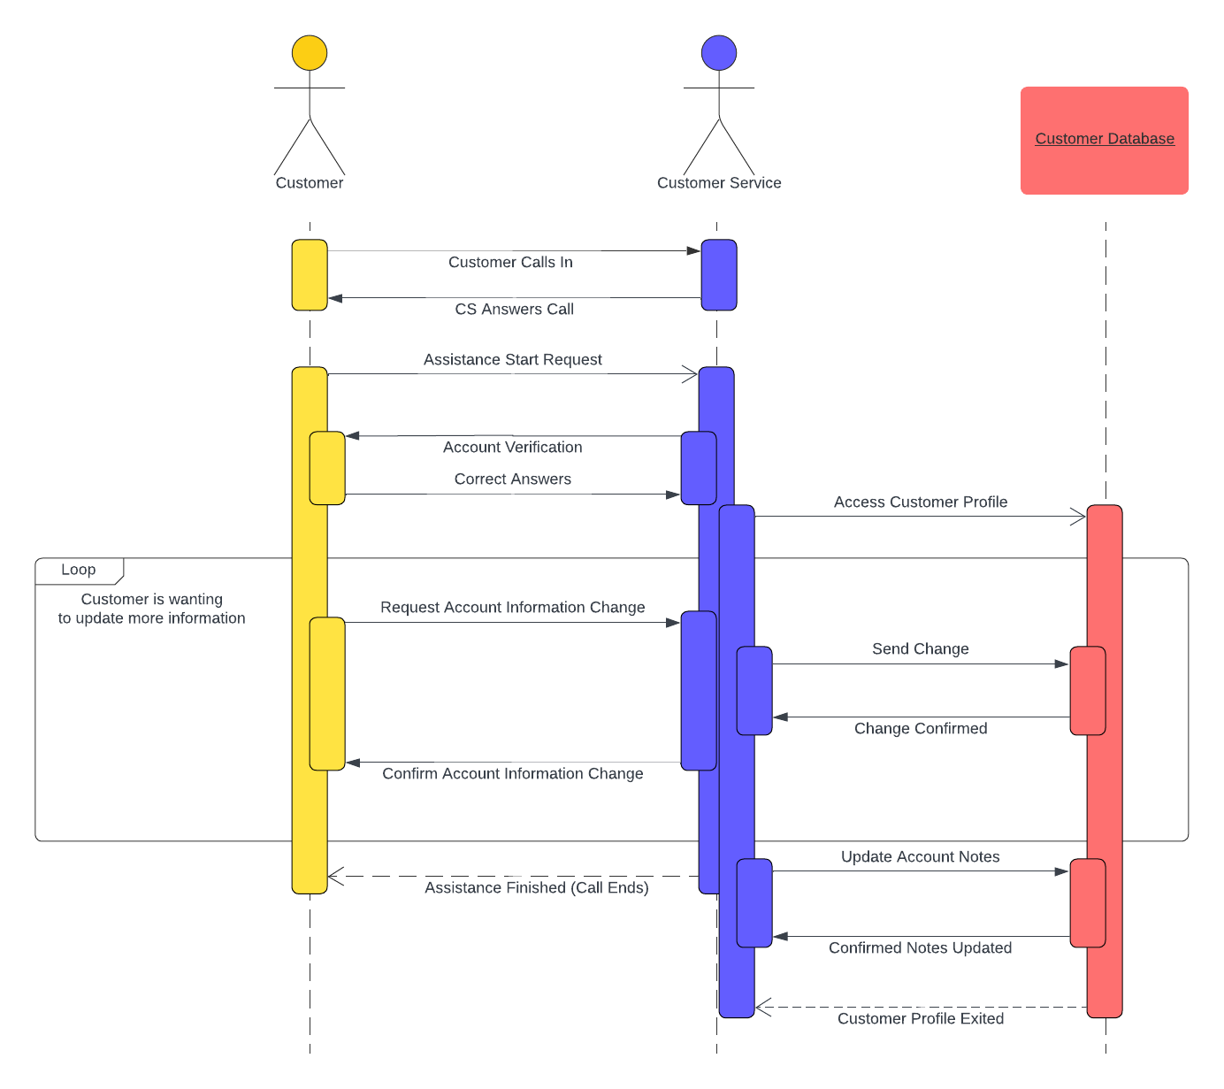

### UML Class Diagram

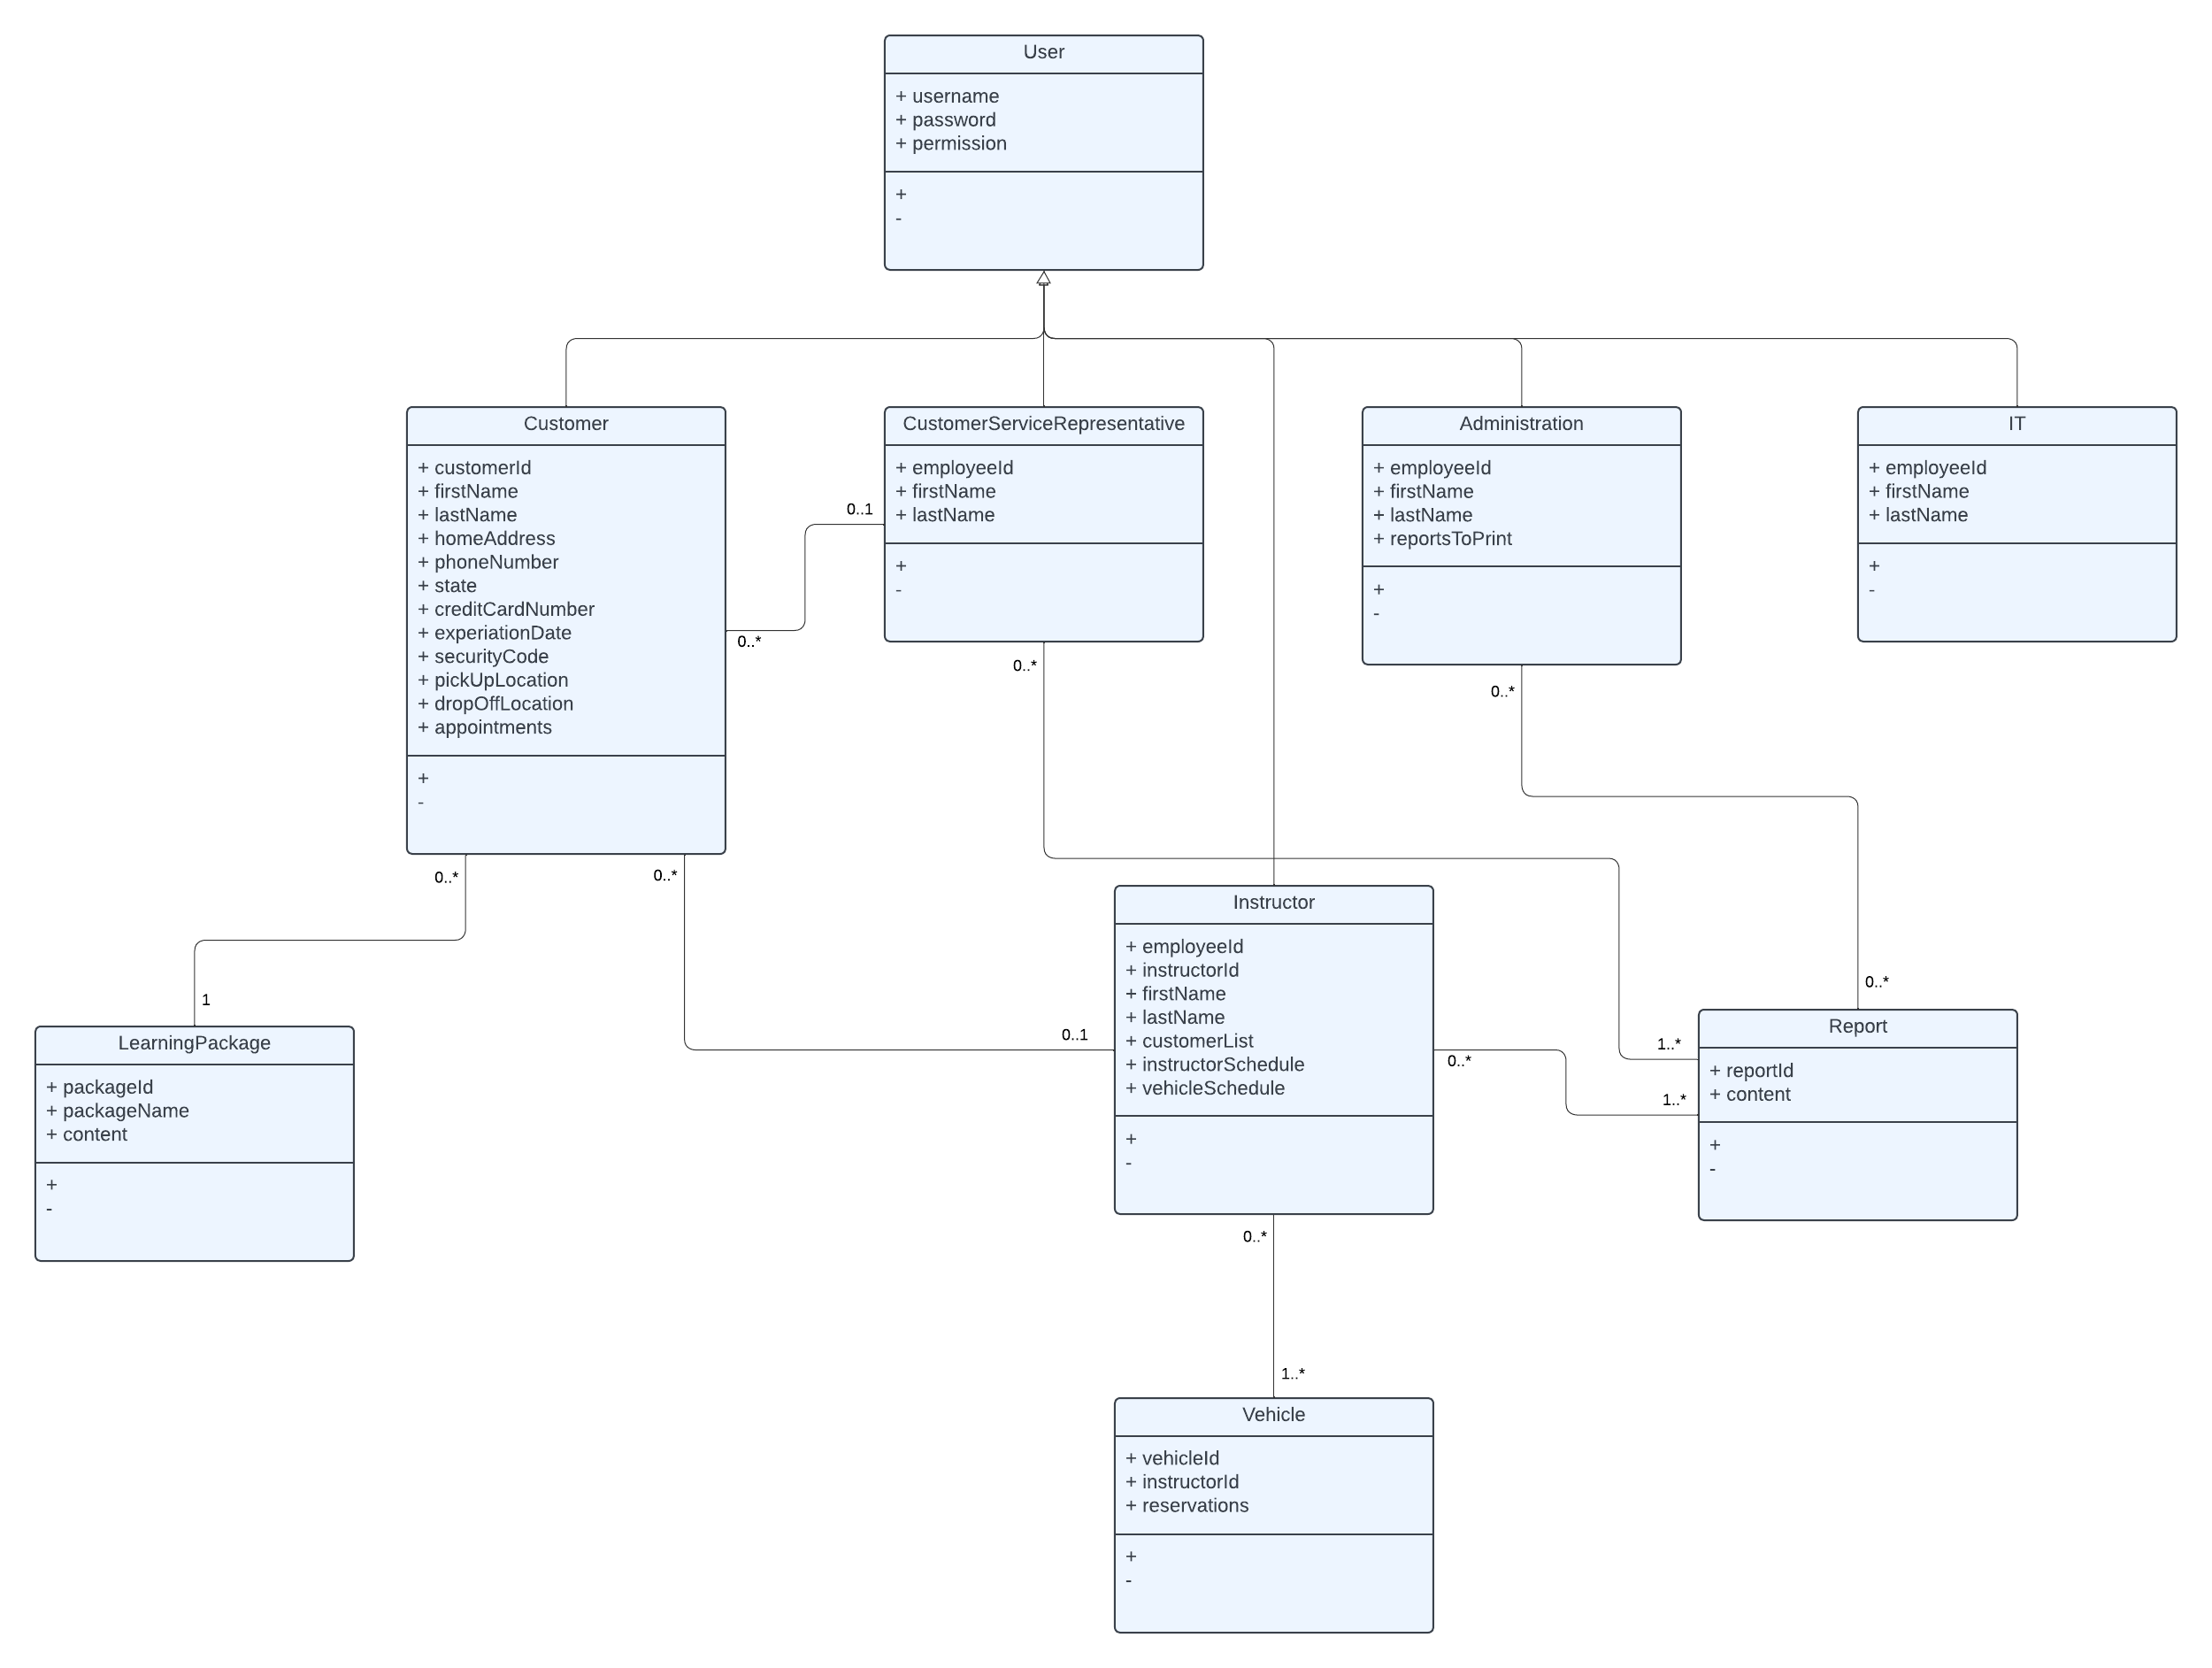

## Technical Requirements

There are some technical requirements for the system as it currently stands. Currently, the system requires phone lines for the customer service team to answer inbound calls as well as computers to interface with a customer’s profile to provide updates at the customer’s request. Administration will also need computers to view reports as well as printers to print off reports. IT will need their computers to interface with the database that, at client request, will be provided by a host service which should have its own tools to interface with the database and servers. IT will also need any software such as integrated development environments and any servicing tools to assist them in maintaining the new systems and network. Since this is for a web-based system, internet access and any modems and routers needed for any on-site networks is a main requirement.

Hardware:

Phone lines for customer service.

Computers for interface with the system.

Printer for reports and other hard copies needed.

Internet modems and routers for connection to external database(s).

Software:

Software for interacting with database remotely for IT.

Separate software for customer service accessing customer profiles to update information.

Tools:

Integrated development environment for development tools

Host-provided/recommended tools to interface with database.

Infrastructure:

Hosting service for database server

Internet service provider